The Agricultural Revolution took place between 8 and 12 thousand years ago all around the globe. The Agricultural Revolution is the domestication of plants and animals. Before the Agricultural Revolution, humans followed and hunted large animals.

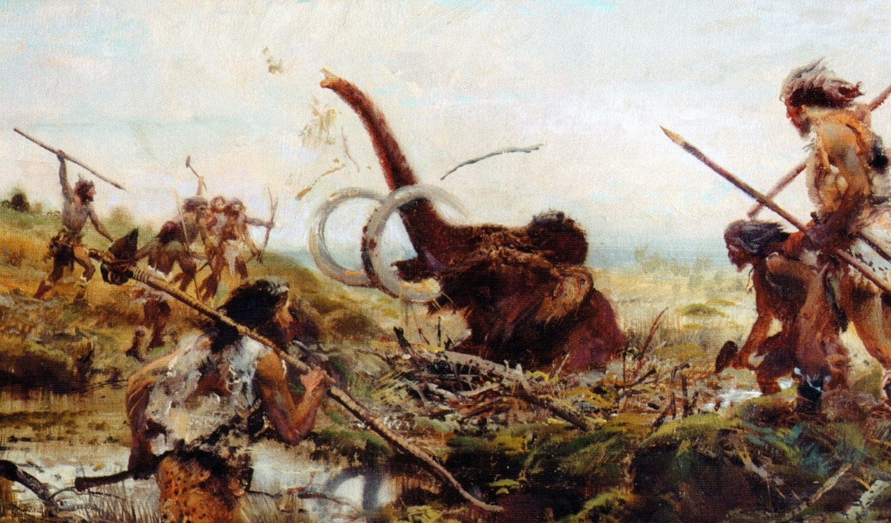
Digital image. N.p., n.d. Web. 9 Nov. 2015. <https://i.ytimg.com/vi/M9OLzXovANA/maxresdefault.jpg>.
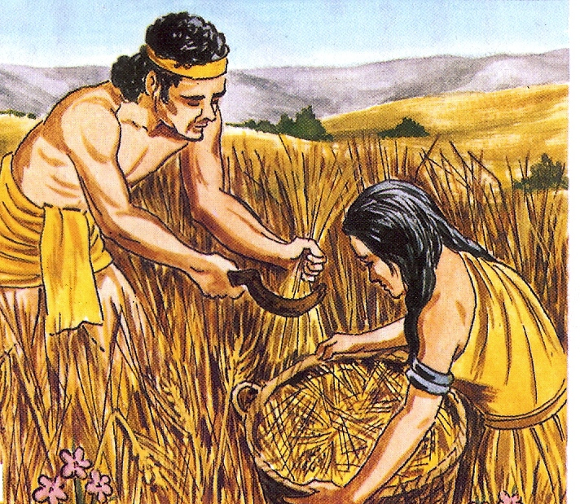
Digital image. N.p., n.d. Web. 9 Nov. 2015. <http://whenintime.com/EventDetails.aspx?e=4a71aa96-7e0e-4bb4-98a4-50880b4b3697&t=/tl/e19hesse/Humanities_6_Review_Timeline/>.

After the Agricultural Revolution, humans started living in one place. Cities sprang up, governments formed, social hierarchies began, economies and job specialization developed, and this eventually led to conflicts and wars over resources.

